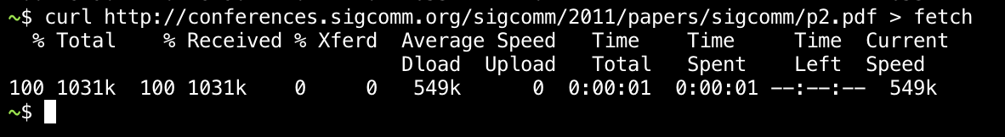

Step3:

Turn-in: Hand in your drawing of a TCP segment.

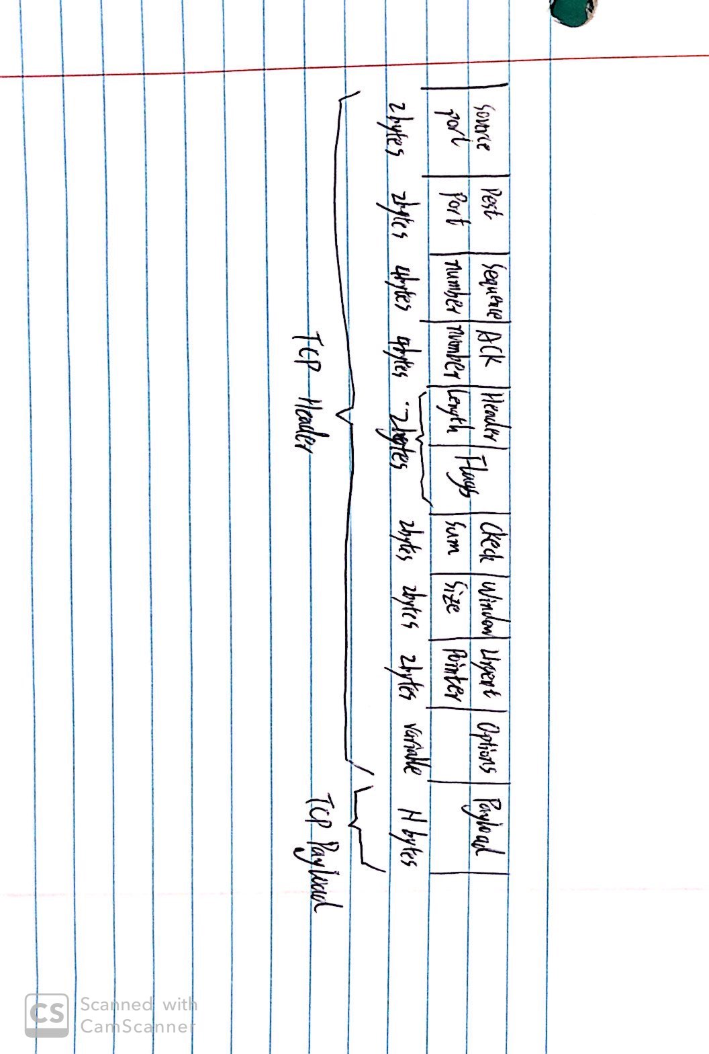

Step 4: TCP Connection Setup/Teardown

*Draw a time sequence diagram of the three-way handshake in your trace, up to and including the first data packet (the HTTP GET request) sent by your computer when the connection is established Put your computer on the left side and the remote server on the right side.* As usual, time runs down the page, and lines across the page indicate segments

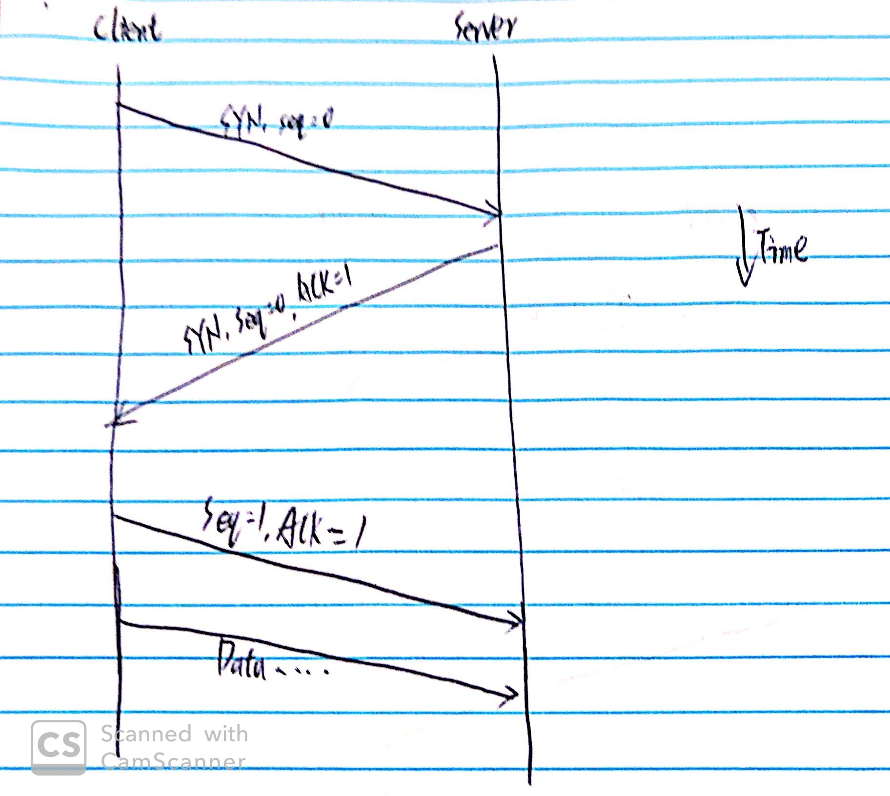

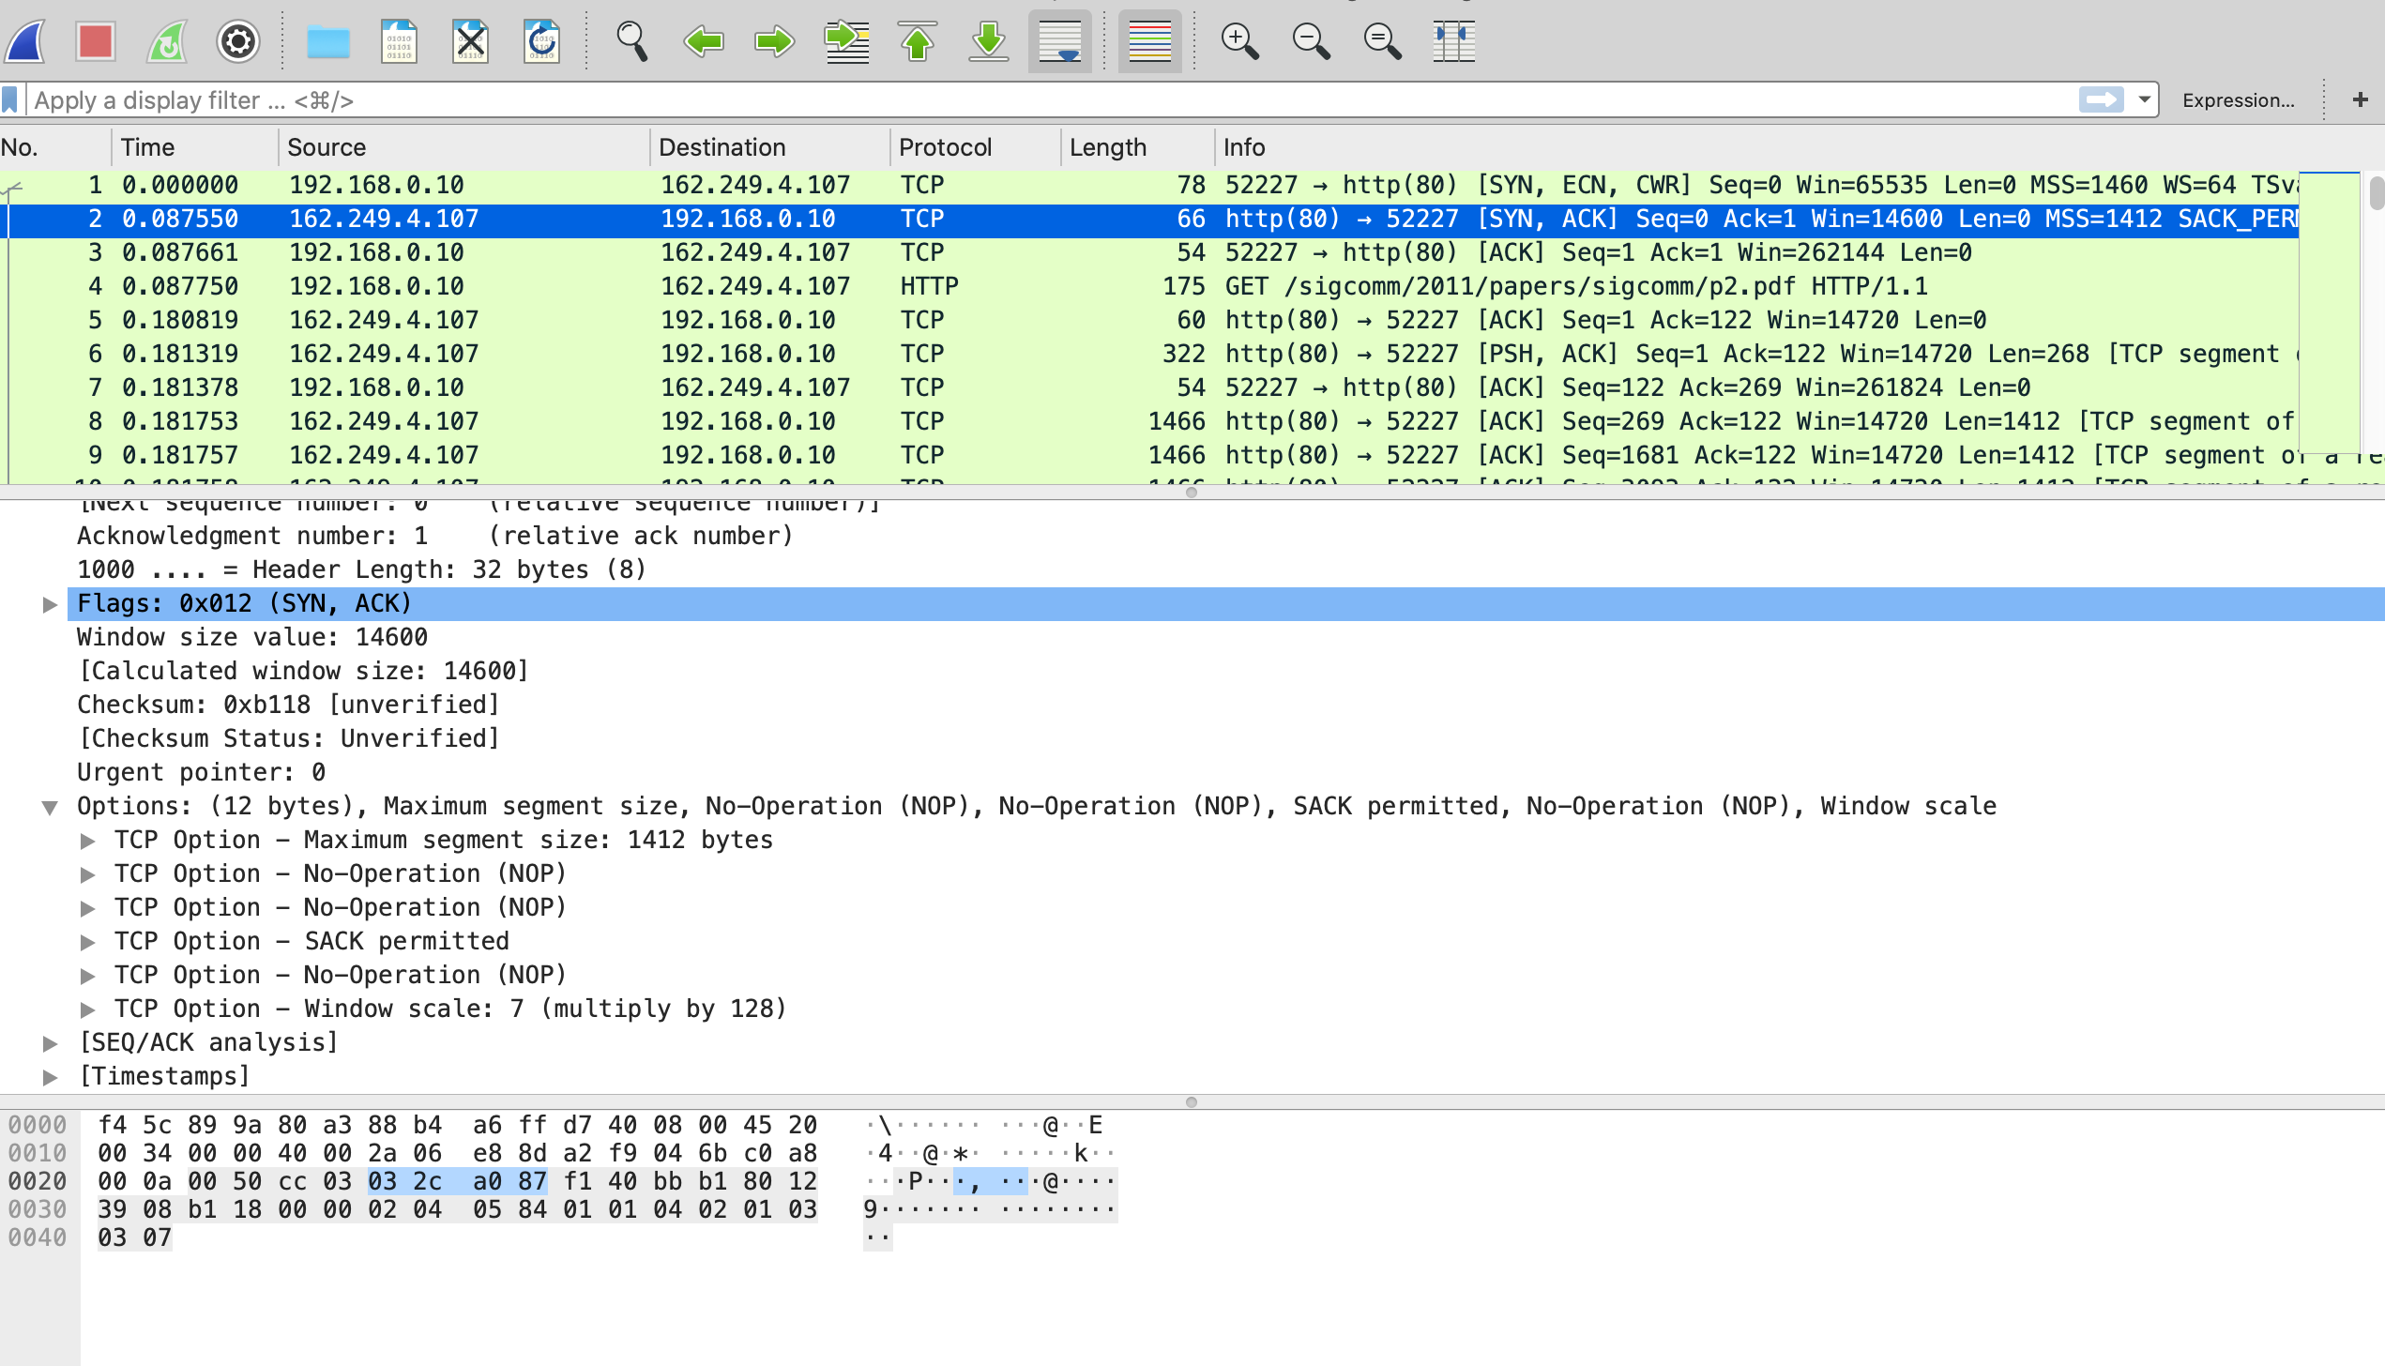

1. What TCP Options are carried on the SYN packets for your trace?

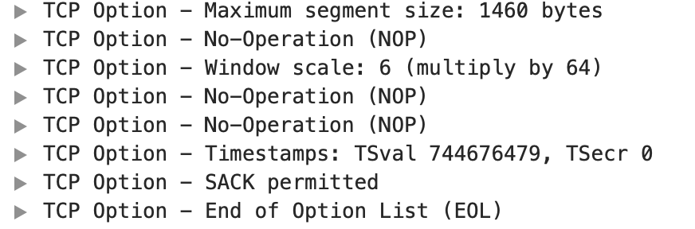

*Draw a picture of the teardown in your trace, starting from when the first FIN or RST is issued until the connection is complete. As before, show the sequence and ACK numbers on each segment. If you have FINs then use the time difference to estimate the round-trip time.* 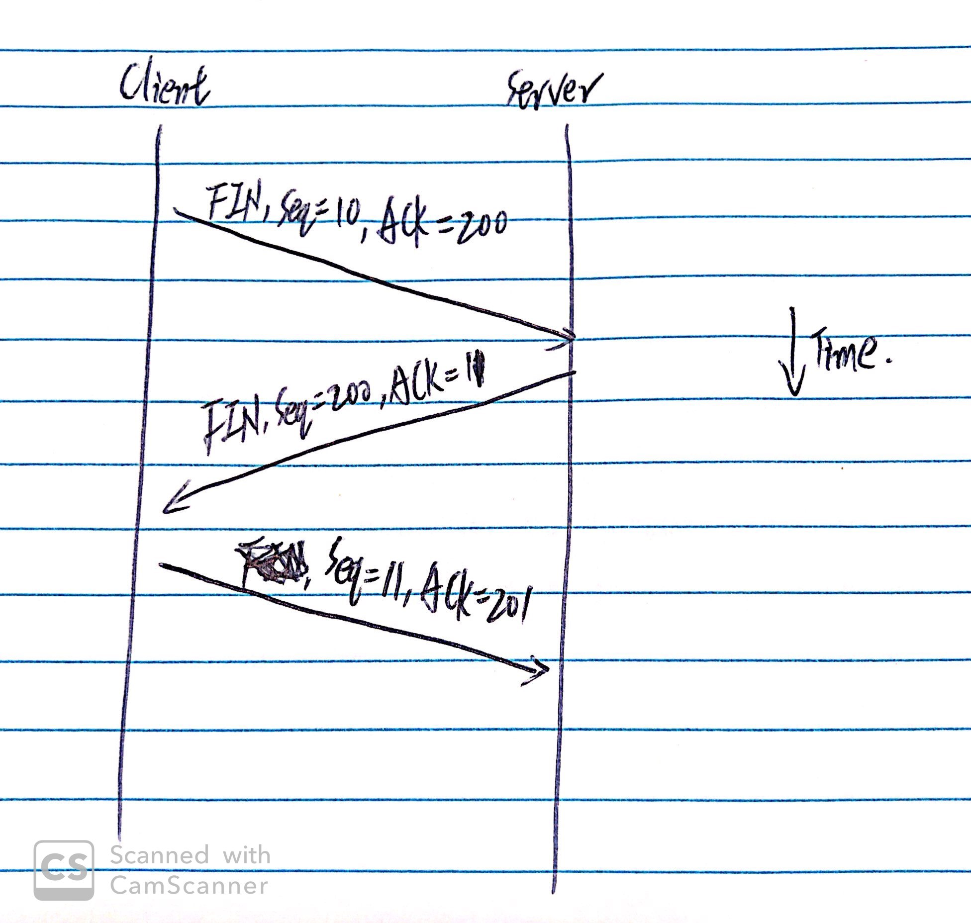

Step 5: TCP Data Transfer

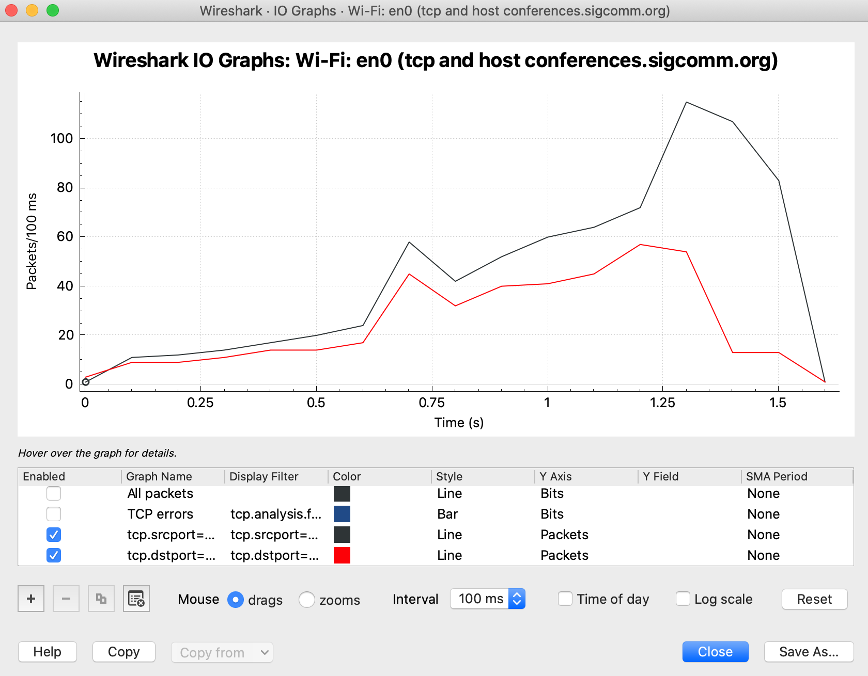

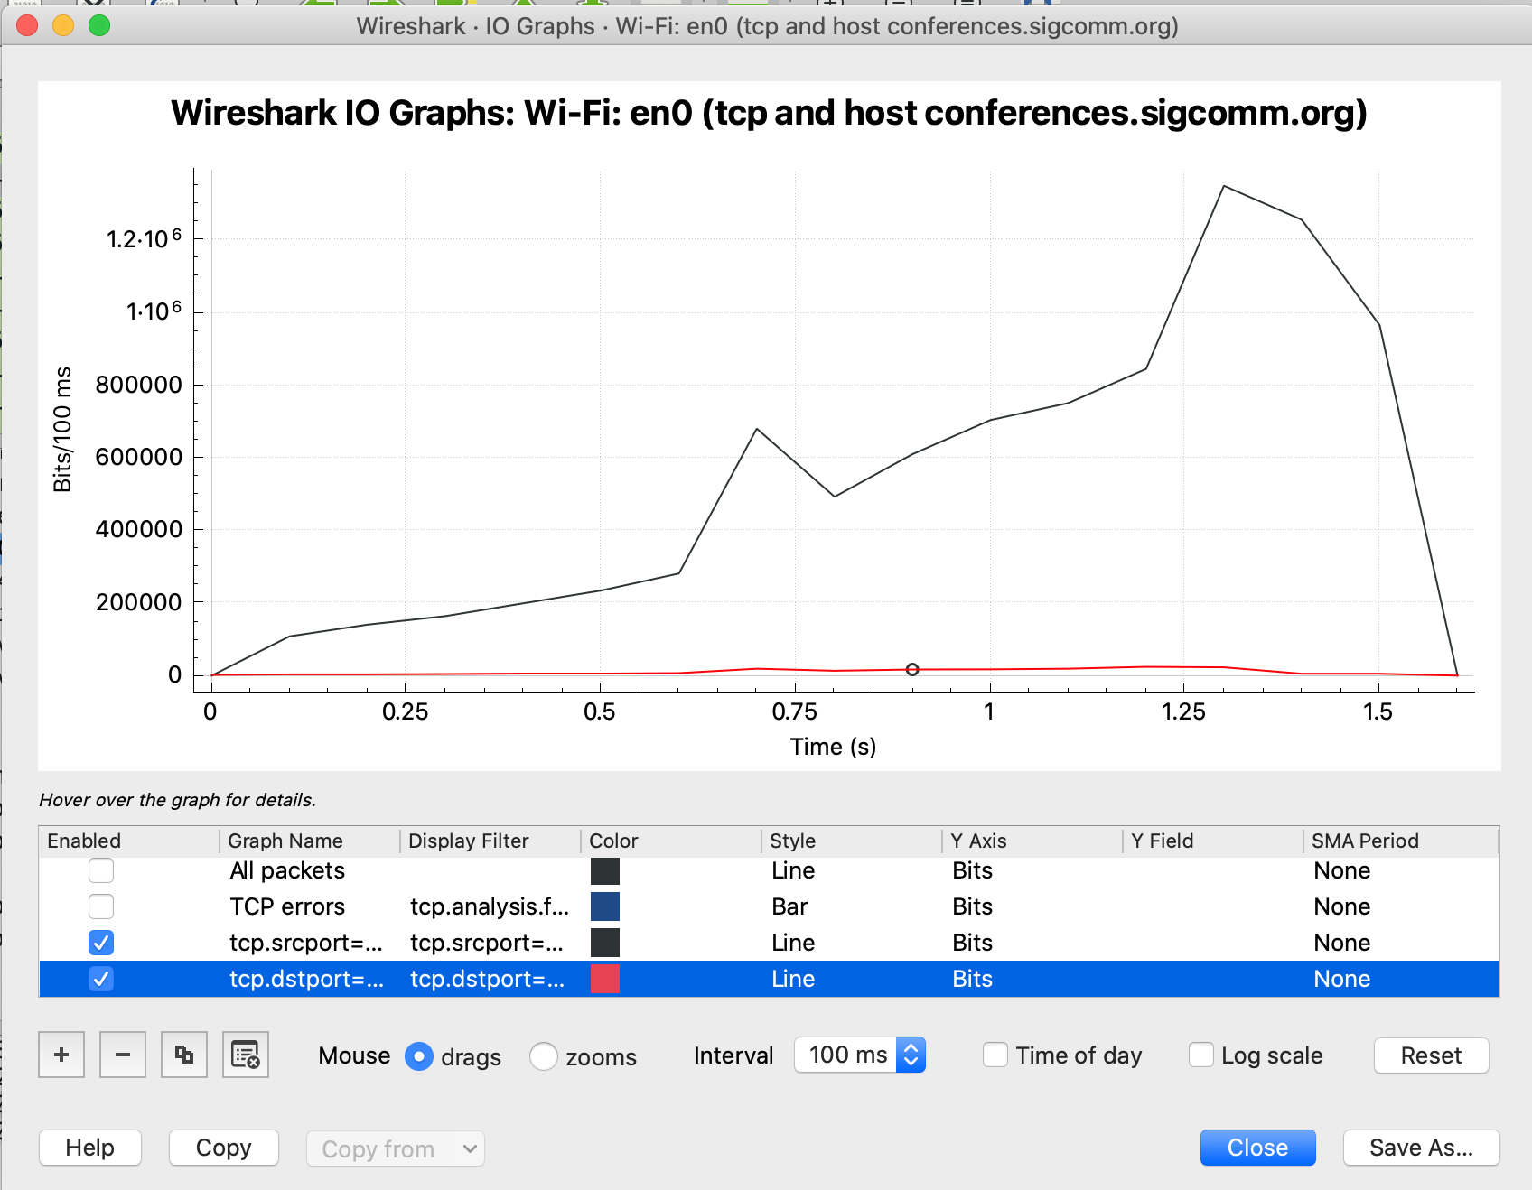

1. What is the rough data rate in the download direction in packets/second and bits/second once the TCP connection is running well?

800 packets/sec

8000000 bits/sec

2. What percentage of this download rate is content? Show your calculation. To find out, look at a typical download packet; there should be many similar, large download packets. You can see how long it is, and how many bytes of TCP payload it contains.

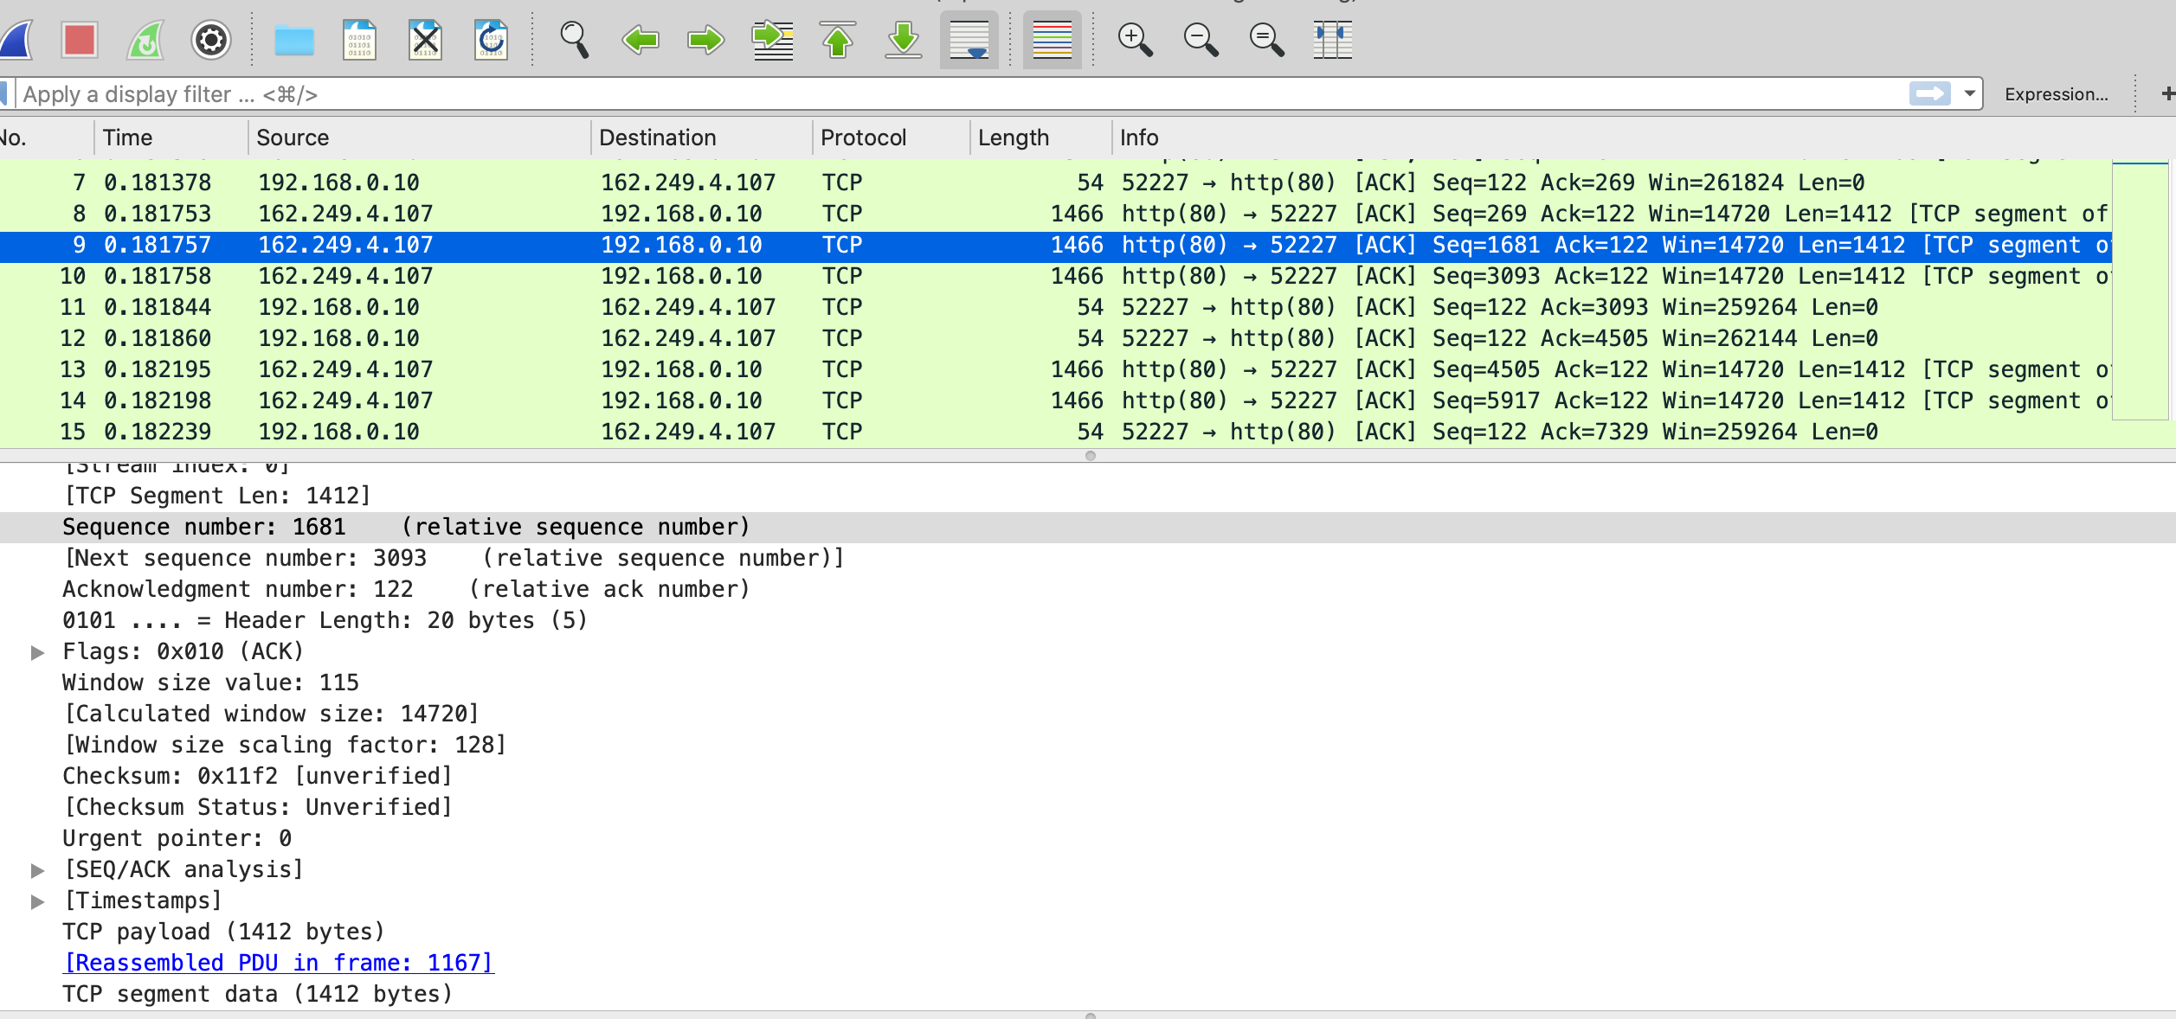

1412 bytes payload, total length is 1466, so rate is 96.3%

3. What is the rough data rate in the upload direction in packets/second and bits/second due to the ACK packets?

400 packets/second

4. If the most recently received TCP segment from the server has a sequence number of X, then what ACK number does the next transmitted TCP segment carry?

The Ack number tells the next expected sequence number so it will be X plus the number of

TCP payload bytes in the data segment.